**Marketplace Builder Hackathon 2025 (Day-2) General E-Commerce Marketplace Plan**

**System Architecture Overview**

The system architecture leverages Next.js for the frontend, Sanity CMS for content management, and third-party APIs for payment processing and shipment tracking. The key objective is to integrate these components in a way that allows for scalability, user-friendly experiences, and smooth transactions.

**Components:**

1. **Frontend (Next.js):** The user interface where customers can browse dresses, customize them, and complete purchases.
2. **Sanity CMS:** Content management system used for managing product data, customer details, and orders.
3. **Third-Party APIs:**
   1. **Payment Gateway (e.g., Stripe):** Handles payment processing.
   2. **Shipment API (e.g., UPS):** Tracks the delivery status of orders.
4. **Product Data API:** Fetches product details from Sanity CMS, including custom design options.

**Example Architecture Diagram:**

* **Frontend (Next.js)**: Handles UI and user interaction.
* **Backend (Sanity CMS)**: Manages products, orders, and customer data.
* **Payment API (Stripe)**: Handles transactions.
* **Shipment API (ShipEngine)**: Handles shipment tracking.

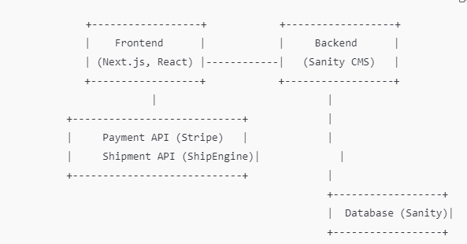

**2. Key Workflows and User Journey**

**1. User Registration Flowchart:**

* **User signs up** → **Sanity CMS stores user data** → **Confirmation email sent** → **User account is created**

**2. Product Browsing Flowchart:**

* **User browses categories or searches** → **Sanity API fetches product data** → **Products displayed dynamically** → **User selects a product**

**3. Order Placement Flowchart:**

* **User customizes a dress** → **Dress added to cart** → **User proceeds to checkout** → **User enters shipping and payment details** → **Order details stored in Sanity CMS** → **Payment processed via Stripe** → **Order confirmed**

**4. Shipment Tracking Flowchart:**

* **Order placed** → **Shipment tracking initiated** → **Third-party API (UPS) fetches status** → **Shipment status displayed on frontend**

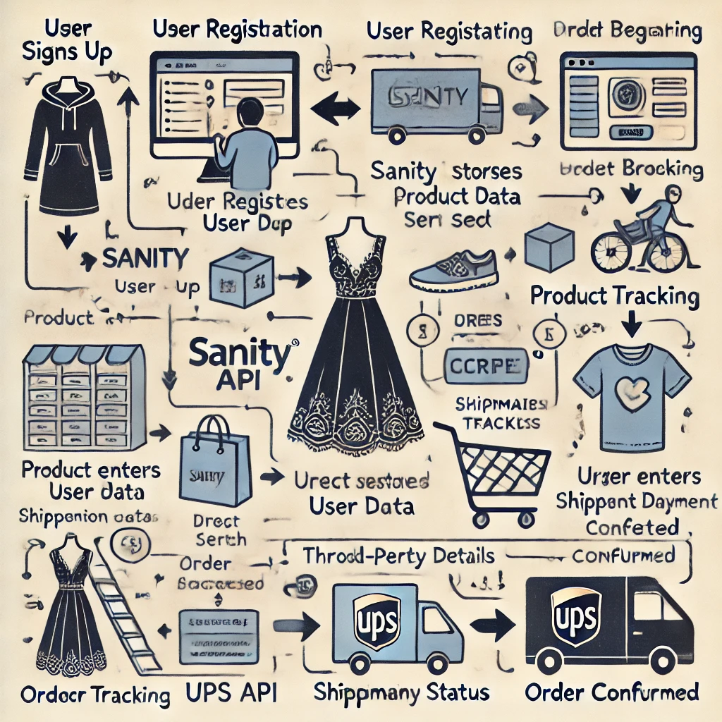

**Flowchart for "Order Placement"**:

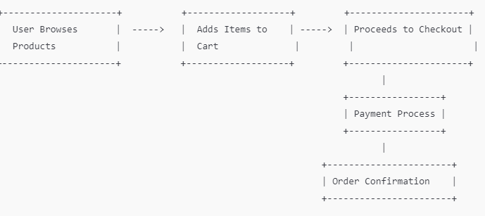

**3. API Endpoints:**

| **Endpoint** | **Method** | **Purpose** | **Response Example** |
| --- | --- | --- | --- |
| /products | GET | Fetches all product details | { "id": 1, "name": "Custom Dress A", "price": 100 } |
| /orders | POST | Create a new order | { "orderId": 123, "status": "Success" } |
| /shipment | GET | Track order status | { "status": "Shipped", "ETA": "2 days" } |

**5. Sanity Schema Example**

* **Product Schema** (for Sanity CMS):

export default {

name: 'product', type: 'document',

fields: [

{ name: 'name', type: 'string', title: 'Product Name' },

{ name: 'price', type: 'number', title: 'Price' },

{ name: 'customizations', type: 'string', title: 'Customization Details' },

{ name: 'stock', type: 'number', title: 'Stock Level' },]};

**4. API Requirements**

1. **/products (GET):**  
   Fetch all product details from Sanity CMS.
   * **Response Example:**

{

"id": 1,

"name": "Custom Design Dress",

"price": 900,

"image": "image_url"

}

1. **/orders (POST):**  
   Submit new order data to Sanity CMS.
   * **Payload Example:**

{

"customerId": "123",

"products": [{ "productId": 1, "quantity": 2 }],

"paymentStatus": "paid"

}

* + **Response Example:**

{

"orderId": 12345,

"status": "success"

}

1. **/shipment (GET):**  
   Fetch real-time shipment status via third-party APIs (e.g., UPS).
   * **Response Example**

{ "orderId": 12345,

"shipmentId": "67890",

"status": "In Transit",

"ETA": "2 days"

}

**5. Sanity CMS Schema Example**

For the product schema in Sanity CMS:

export default {

name: 'product',

type: 'document',

fields: [

{ name: 'name', type: 'string', title: 'Product Name' },

{ name: 'price', type: 'number', title: 'Price' },

{ name: 'stock', type: 'number', title: 'Stock Level' },

{ name: 'image', type: 'image', title: 'Product Image' },

{ name: 'customizationOptions', type: 'array', title: 'Customization Options' }

]

};

**5. System Architecture Diagram (Conceptual)**

This is a simplified diagram to represent the flow:

[Frontend (Next.js)]

|

[Sanity CMS] -----> [Product Data API]

| |

[Third-Party API] -----> [Shipment Tracking API]

|

[Payment Gateway]